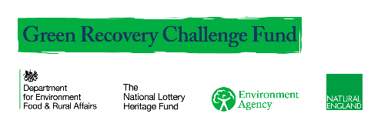
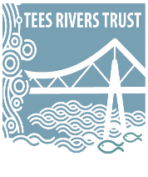
Commercial Development Officer
(Tees Angling Passport)
Job Description

Salary: £25,500 p.a pro rata
Location: Based across North East England
Hours: 20 hours per week

Purpose

To work in a team delivering a package of works in line with grant funding from National Lottery Green Recovery Challenge Fund and specifically to develop a marketing campaign and business buy in to grow and sustain the Trust’ angling passport network along the river Tees.

Main Duties & Responsibilities

As a natural communicator, you will work with businesses, partners, hospitality venues, Tourist Information Centres, local angling clubs, volunteers and any other interested parties to develop sales of the Tees Angling Passport. You will also be tasked with supporting the business development of environmental enhancement and nature-based solutions projects (e.g. Natural Flood Management schemes, river restoration schemes, Invasive Species control). We expect the TAP officer to:
- Travel to project sites across the Tees landscapes in order to review progress of the TAP and strengthen partnerships with delivery organisations, local authorities and landowners.
- Develop the offer of the TAP and generate revenue through sales of advertising;
- Support the identification, assessment and pursuit of new partnership opportunities.
- To work in a flexible manner and to undertake any other duties and responsibilities as may be assigned from time to time, which are commensurate with the grade of the job.
- To carry out all of the above duties with full regard to the Trust’s Equal Opportunities, Non-Discrimination, Safeguarding, Environmental, Health and Safety policies.

The ideal candidate will be highly motivated with the ability to work with minimal supervision; have excellent communication and organisational skills, a good attention to detail and a strong business mindset.

Qualifications

Essential
Educated to degree level or equivalent with experience in developing business opportunities, successful media and social media campaigns and experience of co-ordinating and managing partnerships.

Experience & Knowledge
Essential
Commercial acumen and/or or sales/fundraising experience with experience of contributing to successful client proposals
Excellent interpersonal skills and confident networking skills
Strong commercial awareness coupled with a passion for environmental issues.
Decisive personality and ability to make quick decisions
An ability to think strategically and generate new ideas
Strong English verbal and writing skills
Desirable
At least 3 years’ experience in a relevant field.
Experience of presenting at regional or national events.

Self-Management
Essential
Excellent organisational skills, self-motivation and ability to progress work with limited supervision.
Ability to work to tight deadlines and prioritise workload.
Ability to develop creative solutions and ideas.

Personal Attributes
Essential
A keen interest in, and firm commitment to, conservation and ecology.
A positive team player who is willing to play their part in achieving team targets.
Flexible and adaptable approach with ability to be pragmatic and find creative solutions to problems.
Full driving license and access to own vehicle for work purposes.
Comfortable lone working where necessary.
Able to work occasional weekends and evenings where necessary.

