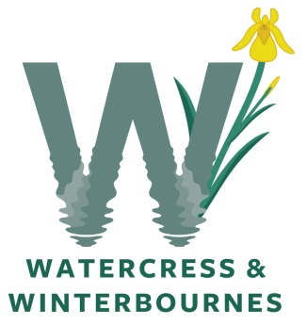
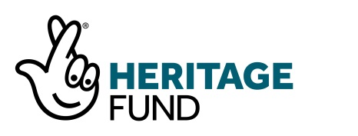

American mink were first imported into the UK and farmed for their fur in 1929 from North America. All the wild mink in Britain today are descendants of escapees that established in the wild in the 1950s and 1960s and now breed across most of the country. Today it is virtually impossible to estimate the number of mink in the UK but populations have thrived and increased rapidly in the last 30-40 years making them common and widespread. Mink are carnivorous mammals feeding on a wide range of mammals, birds and fish, typically about a third of the diet coming from each.

What we are doing?
Hampshire & Isle of Wight Wildlife Trust are leading on development of a National Lottery Heritage Funded project called “Watercress & Winterbournes”. This project covers the headwaters of both the Test & Itchen catchments: Pillhill Brook, the Upper Anton, Bourne Rivulet, Upper Test, Candover Brook, River Arle and Cheriton Stream. It has a number of initiatives which will help improve our water environment, including one to better manage, reduce, and where possible, eradicate invasive non-native species, such as American mink.

Mink will be monitored and trapped using “rafts”. The raft has two modes of action: monitoring and trapping. When monitoring, the mink leaves evidence of a visit in the form of footprints in a clay mixture. Once mink are detected, the raft that gets the footprints is set for trapping and caught individuals are dispatched.

How can you help?
As part of this project, we are looking for volunteers to monitor, trap and dispatch American mink. This will be done through siting rafts along every km of the watercourse within the project area: a total of 85 km! We anticipate only needing a few people to help with dispatching mink.

What support will you receive?
Rafts will be provided by the project. These rafts will need Flood Risk Activity Permits from the Environment Agency which will be secured on your behalf by Hampshire & Isle of Wight Wildlife Trust for all locations.

Training on monitoring and trapping will be provided to all volunteers.

The Hampshire & Isle of Wight Wildlife Trust would like your support for this project, so if you or someone you know is trapping mink, or would like to start or discuss further information with us, please get in touch by contacting Lou Sykes at lou.sykes@hiwwt.org.uk.

We would love to hear from anyone able to support this project by 30th June.

Volunteer name:

Volunteer address:

If you would like to support the Watercress and Winterbournes project, please indicate what role you can play by deleting the relevant text:

Siting a mink raft YES / NO

Monitoring a mink raft YES / NO

Setting a raft to trap mink YES / NO

Dispatching mink YES / NO

