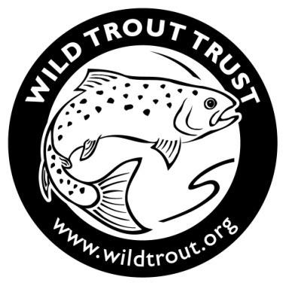
Wild Trout Trust Annual Get-Together
Dartmoor Training Centre, Prince Hall, Princetown PL20 6SA

on Saturday 18 May 2019

To book, please complete and return no later than Tuesday 7 May 2019 to:
The Wild Trout Trust: office@wildtrout.org or PO Box 120, Waterlooville PO8 0WZ.

I would like to attend the WTT Annual Get-Together on Saturday 18 May @ £10 per person, payable on booking
(includes morning coffee & biscuits, lunch, afternoon tea & cake).

Name(s):

Address & Postcode:

Tel and Email:

I would like to fish on Sunday 19 May : Yes / No

Please enclose a cheque, made payable to the Wild Trout Trust, for the appropriate amount or include your debit/credit card details below. Alternatively book online via the WTT Shop.

Name (as it appears on the card): ___________________________________________________

Card No: _____________________________________________

Expiry Date: ___________ Start Date: ________ ____

Security Code (last 3 digits on signature strip) ________ ___ Issue No. _______

Accommodation

Limited bunk beds in dormitories are available at the Dartmoor Training Centre, where WTT staff will be staying. It’s easy, cheap and functional. £20pppn on a first-come-first-served basis. Guests need to bring their own sleeping bag, pillow and towel! The WTT will cook Friday and Saturday evening (eg chilli, bbq) for a small donation at the time.

Please contact Christina with any queries and to book accommodation and/or supper on Friday and/or Saturday nights:
office@wildtrout.org / 023 9257 0985.

Alternative local accommodation which you may wish to book:
Prince Hall Country House, Dartmoor PL20 6SA, tel 01822 890403, www.princehall.co.uk
Forest Inn, Hexworthy PL20 6SD, tel 01364 63211, www.forestinndartmoor.co.uk
Two Bridges Hotel, Princetown PL20 6SW, tel 01822 892300, www.twobridges.co.uk
White Hart Hotel, Moretenhampstead TQ13 8NQ, tel 01647 440500, www.whitehartdartmoor.co.uk

