Wild Trout Trust
Job Description
Assistant Conservation Officer

What and Who We Are After

The Wild Trout Trust (WTT), established in 1997, is a registered charity dedicated to the conservation of wild trout in Britain and Ireland through protection and restoration of habitat.

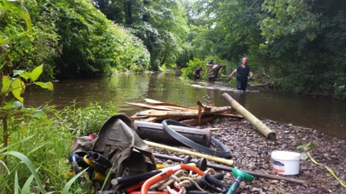

WTT works in both rural and urban catchments with a variety of stakeholder groups including fishing clubs and other community groups, riparian owners, wildlife, rivers and fisheries trusts and the conservation and regulatory agencies. The core conservation role of WTT is the practical delivery of Advisory Visits, demonstration events and river habitat improvement projects, working with these stakeholder groups, to make things better for our rivers and lakes, their iconic wild trout and associated biota, across Britain and Ireland.

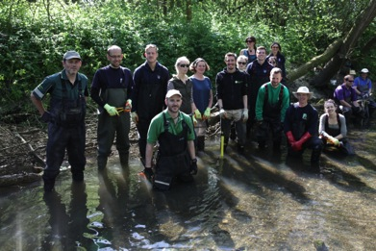

The demand for our work has increased dramatically; we’ve recently employed our seventh Conservation Officer and now we’re looking to appoint an Assistant Conservation Officer to work with, and learn from, two of those officers based in southern England.

This will be a brilliant opportunity for a dynamic, self-starting and focused graduate from a biological, conservation, ecological or fishery management school, with a passion for fisheries, wild rivers and wildlife. You’ll have excellent communication skills (oral and written), a practical aptitude, be physically fit and have an ability to get on with people. You will be part of an expert team, each working from home, though you’ll be under the day-to-day supervision of one of the southern Conservation Officers and WTT’s Director of Operations. You need to be able to manage yourself and have the maturity to complete tasks accurately, effectively and speedily and proactively seek out your next task.

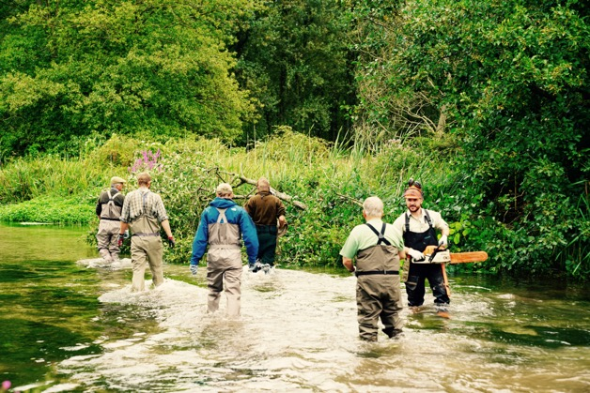

The Assistant Conservation Officer’s role will be (but not limited) to help with Advisory Visits and subsequent reports, the preparation for and delivery of practical projects (including the permitting process), maintenance and preparation of WTT’s practical equipment, responses to e-mail and phone enquiries for advice and the preparation of news items for the WTT website and social media outlets.

You will contribute to the full spectrum of work undertaken by the WTT team such as informal review of other officers’ reports and attendance at key events including technical meetings and shows.

Geographical Range of Work

WTT’s Conservation Officers for the south are currently based in the west of Hampshire and Wiltshire, so you will need a base in, or be willing to move into, the area.

In discussion with the Trust’s Director of Operations, you may also be asked to work in another Conservation Officer’s geographical area.

Terms of Employment

The post will be offered on a full-time basis (37.5 hrs/week) on a fixed-term, 12-month contract, with a 3-month probationary period.

Salary: £15000.

We want to see you grow personally and professionally, so we’ll agree with you a development package, including training and qualifications for your future in practical river conservation e.g. chainsaw use; First Aid. We’re also keen to see you take up membership of an appropriate professional institute e.g. Institute of Fisheries Management.

WTT will provide a contribution to the employee’s pension fund equalling 5% of salary, paid in monthly.

Holiday entitlement: 25 days per annum plus statutory public holidays.

The post will be home-based and you will be expected to travel as required. Your own vehicle is essential, insured for business use and you must have a clean driving licence; mileage expenses at HMRC rates will be claimable for work-related journeys. Wherever practical, the use of public transport should be first choice for all business travel. Other reasonable business expenses, as agreed with the Director of Operations, will be claimable e.g. telephone, internet, equipment, protective clothing. There will be some periods of extended working that may require stays of more than one night away from home.

Summary objectives and job purpose

Assistance with:

- Advisory Visits and the preparation of subsequent reports for fishing clubs, landowners, rivers and wildlife trusts;
- Practical, in-river habitat improvement projects, including the preparation of appropriate permits;
- maintenance and preparation of WTT’s practical equipment, including its trailers, machinery, hand tools and PPE;
- responses to e-mail and phone enquiries for advice;
- preparation of news items for the WTT website and social media outlets;
- partnerships and projects with a wide range of conservation partners and stakeholders, such as the river and wildlife trusts, state conservation and regulatory agencies, fishing clubs and other community groups;
- events highlighting wild trout conservation, e.g. conferences, fishing club meetings;

Relationships

Within WTT:
- Close working relationship with the Conservation Officers for the south and WTT’s Director of Operations;
- Be part of the broader WTT team, including other Conservation Officers and staff;
- Support from the Trust Administrator for payment of expenses, invoicing, etc.

External relationships with:
- Key river environment stakeholders such as the Environment Agency, the river and wildlife trusts, landowners, fishing clubs and conservation volunteers to assist in the identification and prioritisation of projects;
- A network of contacts with potential partners for projects.

WTT Assistant Conservation Officer: Person Profile
 | Essential | Desirable
Education/training/qualifications | Degree in a relevant subject (e.g. biology, conservation, ecology or fishery management). | Degree level education.
Professional skills and attributes | Believe in and implement the values and ethos of WTT.  Understanding of trout habitat requirements.  A good working knowledge and  understanding of angling, landowning, farming and related conservation issues.  Able to write concise and easily understood non-technical reports.  IT Literate. | Practical experience in river habitat restoration and management techniques.  Experience of working or volunteering in the conservation sector.  Member of a professional body such as Institute of Fisheries Management.
Experience | Experience of the world of work, in a paid and/or voluntary capacity. | Experience of working in the voluntary sector, relevant fisheries and habitat management / restoration.
Personal qualities | Mad keen to learn.  A pragmatic approach grounded in a sound scientific background.  Ability to communicate both orally and in writing and work with a broad range of people.  Flexible approach and a willingness to work away from home, including evenings and weekends.  Self-motivated and requiring minimal direction or supervision to achieve objectives.  Ability to work independently from home and as part of a team.  Physically fit and able to cope with or learn quickly a variety of fieldwork and practical tasks.  An empathy with the angling and fisheries fraternity. | A sense of humour.  Good team player.  Determination to find creative and cost-effective solutions.
Additional requirements | Valid, clean driving licence & own car, insured for business use.  Living in the area or willing to move close to WTT’s existing southern Conservation Officers. | Existing access to laptop, mobile phone and broadband connection.

